Supplementary File 2: Eccentric Forms and Meanings
Deities, Lightning, Rain, and Caves
The personification of lightning, known as K’awiil, is typically represented with a long sinuous and serpentine leg, denoting a lightning bolt. The head of K’awiil is perforated by a smoking axe-head or flaming torch, as if struck by lightning (Bassie 2002; Gronemeyer 2003; Hruby 2007; Joralemon 1974; MacLeod and Puleston 1978; Miller and Taube 1993; Stemp and Awe 2014; Stemp et al. 2018, 2019) (Figure 1). Furthermore, in Maya cosmology, Chaahk, the personification of storm and rain, was depicted as brandishing a large stone axe. So emblematic was this axe, that the day referring to this deity, known as Kawak, in the Maya ritual calendar could be represented by the axe-head alone (Freidel et al. 1993:200) (Figure 2).
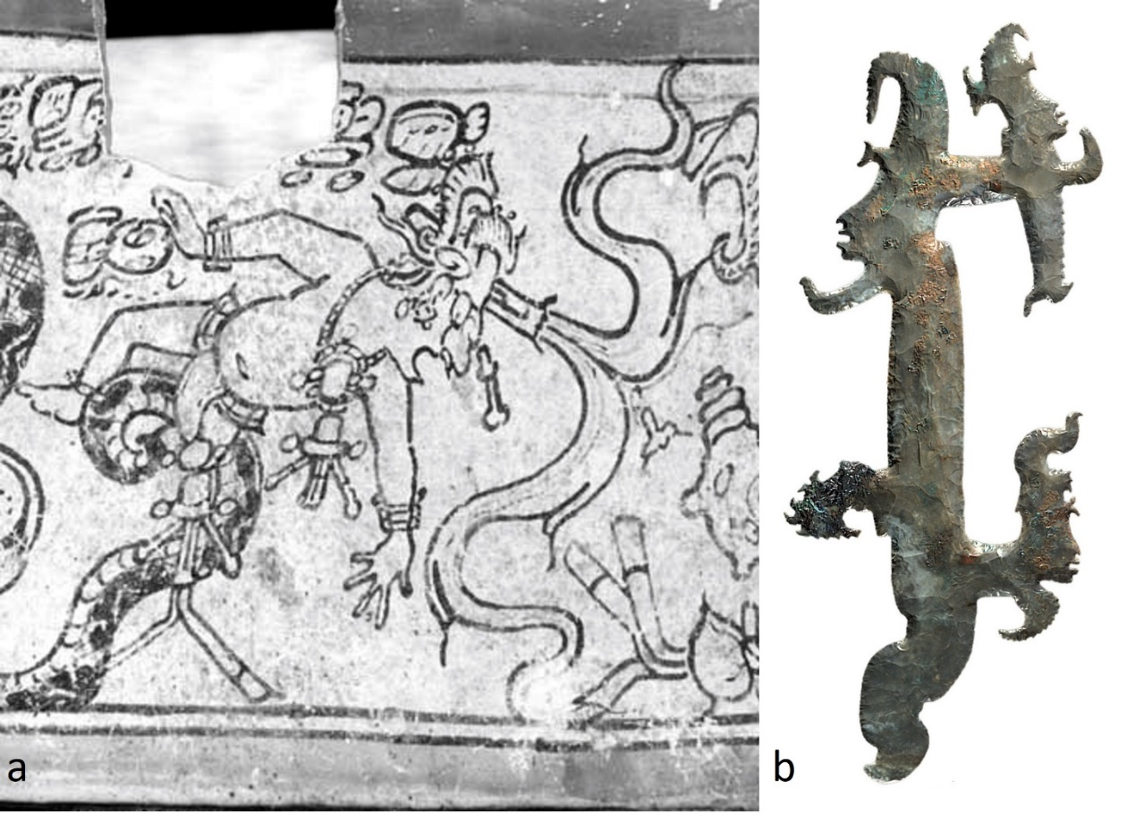

Figure 1. a) Kerr roll-out (K1882) of codex-style pottery vase depicting K’awiil (FAMSI - http://research.mayavase.com/kerrmaya_hires.php?vase=1882); b) chert ‘silhouette’ eccentric (artifact 90-12) from the Rosalila cache, Copan, Honduras (Agurcia-Fasquelle et al. 2016: 17, fig. 8).

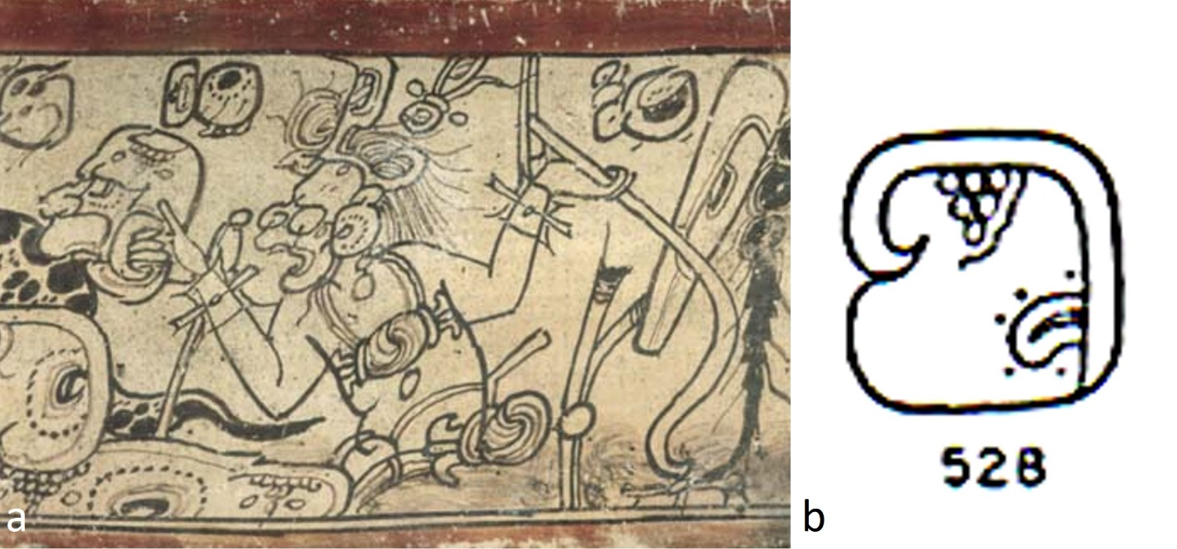
Figure 2. a) Kerr roll-out (K1152) of codex-style pottery vase depicting Chaahk (FAMSI - http://research.mayavase.com/kerrmaya_hires.php?vase=1152) ; b) Kawak glyph (T528) (FAMSI - http://www.famsi.org/mayawriting/thompson/images/t_pg452_150.jpg).

Cosmologically, the Maya conceived of caves and other subterranean spaces as portals to the Underworld, where Maya ancestors and deities of death and fertility resided (Christenson 2007; MacLeod and Puleston 1978). In their cosmology, a number of Maya groups believed that lightning originated in caves, which were also the dwellings of the deities of clouds, maize, rain, rainbows, thunder, and wind (Bassie-Sweet 1991: 79; Brady and Prufer 2005: 369; Christenson 2007; Ishihara 2008; MacLeod and Puleston 1978: 3; Moyes et al. 2009; Palka 2014: 155; Petryshyn 2005: 330; Thompson 1970: 267, 269, 273; Vogt 1969: 387, 457; Vogt and Stuart 2005: 164-165). It was also believed that the first maize was found in mythological caves in which a stone struck by lightning revealed maize kernels (Palka 2014: 157; also see Morehart 2005:175 for maize as “first fruit”). Moreover, the K’iche’ Maya believed that a maize seed was split open by a lightning bolt at the time of germination (Bassie 2002: 8). As such, there are strong symbolic connections between, stone, lightning, caves, and maize in Maya cosmology. Because caves were thought of as sources of clouds and rain, as well as grains of maize and other domesticated plants, eccentrics placed in caches, burials, and caves are linked to the return of celestial lightning bolts to the creators, among other meanings.
Given both the connections of chert and obsidian to lightning, stone tools may manifest in some cases as a deification of K’awiil, the deity of lighting (Agurcia-Fasquelle et al. 2016; Bassie 2002; Colas et al. 2000; Gronemeyer 2003; Hruby 2007; Joralemon 1974; MacLeod and Puleston 1978; Miller and Taube 1993; Stemp and Awe 2014; Stemp et al. 2018, 2019). This type of symbolic connection can be demonstrated by chert eccentrics that depict figures in profile, the forehead of which are penetrated by a smoking axe. Whereas this is one of the major attributes of K’awiil, interestingly post-mortem aspects of deified ancestors are thought of as syntheses of K’awiil and the young maize deity Ajan. It is in this aspect as Ajan-K’awiil that deified human ancestors are represented with the axe-head of K’awiil embedded in their foreheads (Colas 2009). Along with K’awiil, the likenesses of other deities, such as that of rain, the sun and the moon goddess also occur on incised obsidian eccentrics Chaahk, K’inich Ajaw and Ix Chel, as well as the woven mat (or Pop) motif, which represents royal power, also occur on incised obsidian eccentrics (Hruby 2007; Iannone 1992; Iannone and Conlon 1993; Moholy-Nagy 2008; Stone and Zender 2011: 83) (Figure 3).

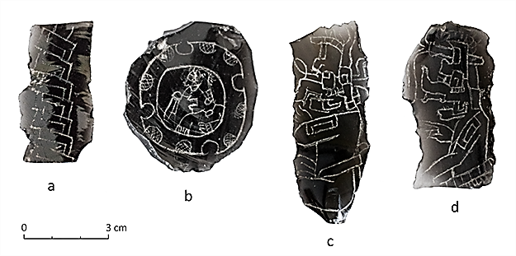

Figure 3. a) incised obsidian flake-blade eccentrics from Tikal, Guatemala (from left to right) - royal mat motif, sun god K’inich Ajaw, thunder deity Chaahk, and personification of lightning K’awiil (photo by C. Helmke).

Zoomorphs
Simultaneously or alternatively, zoomorphs may represent other aspects of Maya ideology and cosmology. Serpentine forms of eccentrics may represent the snake foot of K’awiil as lightning that strikes the ground and likely have associations with the sky, as well as skeletal centipedes associated with the Underworld (Figure 4). Occasionally, chipped stone bifaces (laurel-leaf bifaces) are depicted as the bicephalous ends of a ruler’s serpent bar (Figure 5a), which in turn is a diminutive representation of the celestial band (Clancy 1984; Schele and Miller 1986). It may also be that the serpent bar itself was chipped from a large piece of chert as demonstrated by a few examples from El Chiquero, Hats Kaab, Lamanai, and Santa Rita Corozal (Chase 1992; Chase and Chase 2005; Pendergast 2006; Runggaldier et al. 2013; Stemp et al. 2014) (Figure 5b). In addition to centipedes (Figure 6a), other zoomorphs that share connections to the Underworld are bats, scorpions (Figure 6b), and spiders. All can be considered subterranean-dwellers or cave creatures that appear in the K’iche’ Maya creation myth the Popol Vuh (Christenson 2007). The deity of death (God A) is often depicted accompanied by creatures of the night, darkness, and the underworld, such as scorpions, spiders, centipedes, and bats. In Maya iconography, the bony jaw of the entrance to the Underworld is associated with the centipede (Schele and Mathews 1998; Schele and Miller 1986), an entity that is also tied to heat and thereby to solar rays (Taube 2003).

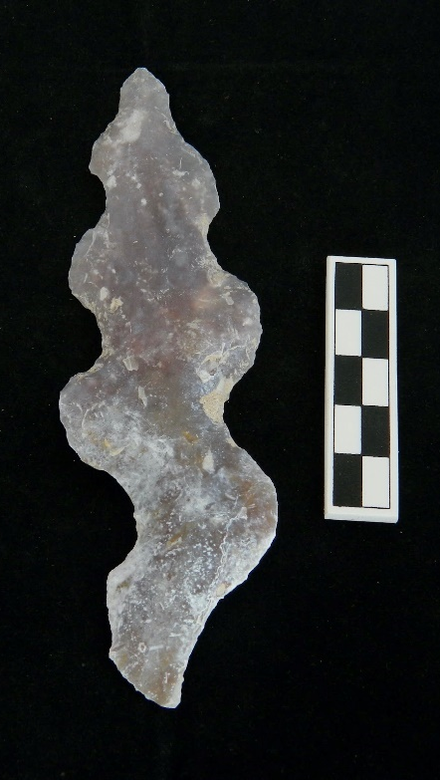
Figure 4. small chert ‘serpent’ eccentric from Cache 3, Ballcourt 2 at Xunantunich, Central Belize (photo by J.A. Lee).

Figure 5. a) ruler with double-headed serpent bar on Stela 10, Seibal, Guatemala (Miller 1996); b) large chert eccentric macroliths from Lamanai (left) and Hats Kaab, Central Belize (Stemp et al. 2014: 147, Fig. 3).

Figure 6. a) small chert ‘centipede’ eccentric from Cache 1, Ballcourt 2 at Xunantunich, Central Belize; b) small chert ‘scorpion’ eccentric from Cache 1, Ballcourt 2 at Xunantunich, Central Belize (photos by J.A. Lee).

Disks, Crescents, Quadripartites, and Triadics
Eccentric forms representative of the sun and other astral bodies are numerous and varied. Disks, rings, or crescents have been interpreted as representations of the sun and possibly eclipses (Meadows 2001) (Figure 7a-c). Moreover, sun-shaped eccentrics may be representative of solar kings, tied to the great deity K’inich Ajaw (Schele and Freidel 1990) or to the nocturnal sun as the underworld jaguar (Schele and Miller 1986). Crescents may be representative of the moon, particularly the association with Ix Chel, the Moon goddess, who is often depicted sitting in a crescent moon (Stone and Zender 2011:147).
Other crosses or quatrefoil forms may be associated with cardinal directions and the K’an cross in particular (Figure 7d, e). The K’an cross is the diagnostic element of the glyph for ‘yellow’ (Stone and Zender 2011: 127), the colour associated with the southern cardinal direction. The K’an cross is connected to world order, notably the four cardinal directions of the Maya world with the Wakah-chan or the axis mundi in the centre. Quadripartite divisions are also strongly linked to caches, burials, and caves (Freidel et al. 1993; Guernsey 2010; Mathews and Garber 2004; Otto 1995; Schele and Miller 1986).
Triadic or tripartite forms are likely connected to cosmology and beliefs about ancestry, origins, and rulership (Freidel et al 1993; Looper 1995; Wauchope 1938) (Figure 7f). The three cooking hearth stones supporting a comal likely represent the three stone thrones of creation in Maya creation mythology (Freidel et al. 1993; Taube 1998). Among the K’iche’ Maya, the “three stone place” or “first three stone place” may also be connected to astral bodies, specifically the three stars around the constellation Orion (Freidel et al. 1993; Tedlock 1985).

Figure 7. a) small chert ‘ring’ eccentric from Cache 1, Ballcourt 2 at Xunantunich, Central Belize; b) small chert ‘crescent’ eccentric from Cache 1, Ballcourt 2 at Xunantunich, Central Belize; c) small chert ‘serrated crescent’ eccentric from Cache 1, Ballcourt 2 at Xunantunich, Central Belize; d) small chert ‘quatrefoil/quadripartite’ eccentric from Cache 3, Ballcourt 2 at Xunantunich, Central Belize e) small chert ‘serrated quatrefoil’ eccentric from Cache 4, Ballcourt 2 at Xunantunich, Central Belize; F) small chert ‘tripartite’ eccentric from Cache 3, Ballcourt 2 at Xunantunich, Central Belize (photos by J.A. Lee).

Anthropomorphs

Various anthropomorphs are represented by eccentrics, including the aforementioned silhouette or elaborate eccentrics, as well as others that may be depictions of ballplayers (Meadows 2001), ancestors, captives, or mythic actors (Figure 8).

Figure 8. a) small chert ‘anthropomorph’ eccentric from Cache 1, Ballcourt 2 at Xunantunich, Central Belize; b) small chert ‘anthropomorph’ eccentric from Cache 1, Ballcourt 2 at Xunantunich, Central Belize (photos by J.A. Lee).
Hieroglyphs
As previously noted, eccentrics may represent Maya hieroglyphs. The small eccentric from Actun Uayazba Kab is chipped from a blade segment made from green Pachuca obsidian and was recovered in association with a cave burial (Figure 9b). This artifact compares in form and outline to the glyph k’ik’ or ‘blood’ (Stemp et al. 2012) (Figure 9a). If the eccentric is meant to be a representation of the glyph for blood, this would fit well with reconstructions of symbolic value. The ancient Maya used lancets made from obsidian to pierce various body parts in acts of auto-sacrifice to provide blood to the supernatural. This was undertaken as part of religious rituals, often in caves, as attested to by multiple sources of evidence (Awe et al. 2005; Colas et al. 2000; Pendergast 1974; Stemp and Awe 2014; Stemp et al. 2019).

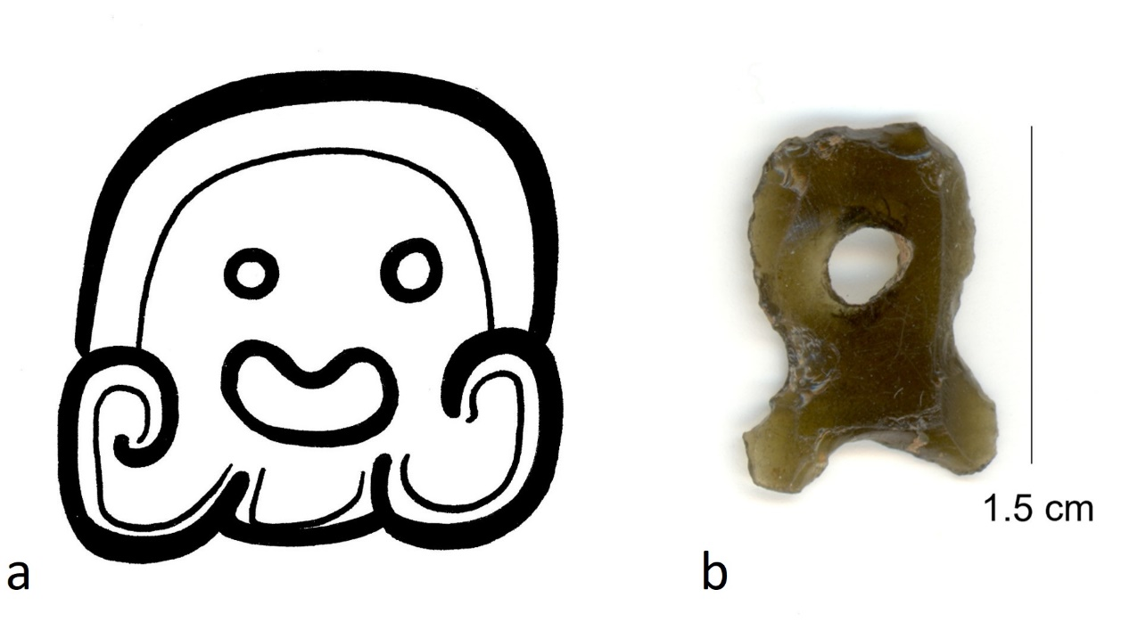
Figure 9. a) logogram glyph (T628) for k’ik’ ‘blood’ (drawing by C. Helmke); b) small green eccentric from Actun Uayazba Kab (photo by W.J. Stemp).

Notched Forms
Eccentrics also possess notches, often on the top or bottom edges that may refer to particular cosmological concepts or personages. A cleft on the top of an eccentric may be a reference to witz, ‘mountain’, indicating a connection to the physical landscape or culturally charged symbolic landscapes (e.g., Friedel et al. 1993; Stuart 1997). Three notches or clefts at the top of an eccentric may also be represent a tri-pronged form of the so-called Jester God, an early symbol of rulership (Stuart 2012) and cosmological realms (i.e., terrestrial, celestial, and aquatic) united by the ruler, possibly also referencing the world tree or centre (Steinback 2015; Taube 1998: 454).

References
Agurcia Fasquelle, R., Sheets, P. & Taube, T.A. 2016, Protecting Sacred Space: Rosalila’s Eccentric Chert Cache at Copan and Eccentrics among the Classic Maya. Precolumbian Mesoweb Press, San Francisco, 152 p.

Awe, J.J., Griffith, C. & Gibbs, S. 2005, Cave Stelae and Megalithic Monuments in Western Belize. In In the Maw of the Earth Monster: Mesoamerican Ritual Cave Use (Brady, J.E. & Prufer, K.M., Eds.), University of Texas Press, Austin: p. 223-249.

Bassie-Sweet, K. 1991, From the Mouth of the Dark Cave: Commemorative Sculpture of the Late Classic Maya. University of Oklahoma Press, Norman, 297 p.

Bassie-Sweet, K. 2002, Maya Creator Gods. Mesoweb. Retrieved 8/28/2019. URL: www.mesoweb.com/features/bassie/CreatorGods/CreatorGods.pdf

Brady, J E. & Prufer, K.M. 2005, Maya Cave Archaeology: A New Look at Religion and Cosmology. In Stone Houses and Earth Lords: Maya Religion in the Cave Context (Prufer, K.M. & Brady, J.E., Eds.), University Press of Colorado, Boulder: p. 365-379.

Chase, A.F. 1992, Elites and the Changing Organization of Classic Maya Society. In Mesoamerican Elites: An Archaeological Assessment (Chase, D.Z. & Chase, A.F., Eds.), University of Oklahoma Press, Norman: p. 30-49.

Chase, D.Z. & Chase, A.F. 2005, The Early Classic Period at Santa Rita Corozal: Issues of Hierarchy, Heterarchy and Stratification in Northern Belize. Research Reports in Belizean Archaeology 2: 111-129.

Christenson, A.J. 2007, Popol Vuh: Sacred Book of the Quiché Maya People. Mesoweb. Retrieved 2/17/2019. URL: www.mesoweb.com/publications/Christenson/PopolVuh.pdf

Clancy, F.S. 1984, Classic Maya Ceremonial Bar. Anales del Instituto de Investigaciones Esteticas, 16(65): 7-45. (in Spanish) (“Annals of the Institute for Aesthetic Studies”)

Colas, P.R. 2009, Deities of Transition: Death Gods among the Classic Maya. In The Maya and their Sacred Narratives: Text and Context in Maya Mythologies (Le Fort, G., Gardiol, R., Matteo, S. & Helmke, Eds.), Acta Mesoamericana 20, Verlag Anton Saurwein, Markt Schwaben: p. 197-205.

Colas, P.R., Reeder, P. & Webster, J. 2000, The Ritual Use of a Cave on the Northern Vaca Plateau, Belize, Central America. Journal of Cave and Karst Studies, 62(1): 3-10.

Freidel, D., Schele, L. & Parker, J. 1993, Maya Cosmos: Three Thousand Years on the Shaman’s Path. William Morrow, New York, 543 p.

Gronemeyer, S. 2003, Bloodletting and Vision Quest Among the Classic Maya: A Medical and Iconographic Reevaluation. Human Mosaic, 34(1&2): 5-14.

Guernsey, J. 2010, A Consideration of the Quatrefoil Motif in Preclassic Mesoamerica. RES: Anthropology and Aesthetics, 57&58: 75-96.

Hruby, Z.X. 2007, Ritualized Chipped-stone Production at Piedras Negras, Guatemala. In Rethinking Craft Specialization in Complex Societies: Archaeological Analyses of the Social Meaning of Production (Hruby Z.X. & Flad, R.K., Eds.), Archaeological Papers of the American Anthropological Association, No. 17, American Anthropological Association, Washington, D.C.: p. 68-87.

Iannone, G. 1992, Ancient Maya Eccentric Lithics: A Contextual Analysis. M.A. thesis at the Department of Anthropology, Trent University, Peterborough, 306 p.

Iannone, G. & Conlon, J.M. 1993, Elites, Eccentrics, and Empowerment in the Maya Area: Implications for the Interpretation of a Peripheral Settlement Cluster Near Cahal Pech, Cayo District, Belize. Papers from the Institute of Archaeology 4: 77-89.

Ishihara, R. 2008, Rising Clouds, Blowing Winds: Late Classic Maya Rain Rituals in the Main Chasm, Aguateca, Guatemala. World Archaeology, 40(2): 169-189. Doi: 10.1080/00438240802030001

Joralemon, D. 1974, Ritual Blood-sacrifice Among the Ancient Maya: Part 1. In: Primera Mesa Redonda de Palenque (First Palenque Round Table), Part II (Robertson, M.G., Ed.), Robert Louis Stevenson School, Pebble Beach: p. 59-75.

Looper, M.G. 1995, The Three Stones of Maya Creation Mythology at Quiriguá. Mexicon, 17(2): 24-30.

MacLeod, B. & Puleston, D.E. 1978, Pathways into Darkness: The Search for the Road to Xibalba. In Tercera Mesa Redonda de Palenque, Vol. 4 (Robertson, M.G. & Jeffers, D.C., Eds.), Herald Peters, Monterey: p. 71-77. (in Spanish) (“Third Palenque Round Table”)

Mathews, J.P. & Garber, J.F. 2004, Models of Cosmic Order: Physical Expression of Sacred Space among the Ancient Maya. Ancient Mesoamerica, 15(1): 49-59. doi: 10.1017/S0956536104151031.

Meadows, R.K. 2001, Crafting K’awil: A Comparative Analysis of Maya Symbolic Flaked Stone Assemblages from Three Sites in Northern Belize. Ph.D. thesis at the Department of Anthropology, University of Texas, Austin, 674 p.

Miller, M.E. 1996. The Art of Mesoamerica: From Olmec to Aztec. Thames and Hudson, London, 240 p.

Miller, M. & Taube, K. 1993, The Gods and Symbols of Ancient Mexico and the Maya: An Illustrated Dictionary of Mesoamerican Religion. Thames and Hudson, London, 216 p.

Moholy-Nagy, H. 2008, The Artifacts of Tikal: Ornamental and Ceremonial Artifacts and Unworked Material. Tikal Report No. 27, Part A. University Museum Monograph 127. University of Pennsylvania Museum of Archaeology and Anthropology, Philadelphia, 260 p.

Morehart, C.T. 2005, Plants and Caves in Ancient Maya Society. In Stone Houses and Earth Lords: Maya Religion in the Cave Context (Prufer, K.M. & Brady, J.E., Eds.), University Press of Colorado, Boulder: p. 167-185.

Moyes, H., Awe, J.J. Brook, G.A. & Webster, J.W. 2009, The Ancient Maya Drought Cult: Late Classic Cave Use in Belize. Latin American Antiquity, 20(1): 175-206. doi: 10.1017/S1045663500002571

Palka, J.W., 2014 Maya Pilgrimage to Ritual Landscapes: Insights from Archaeology, History, and Ethnography. University of New Mexico Press, Albuquerque, 392 p.

Otto, B.E. 1995, The Eccentrics of Buenavista: Typology, Terminology, and Meaning. M.A. thesis at the Department of Anthropology, San Diego State University. San Diego, 188 p.

Pendergast, D.M. 1974, Excavations at Actun Polbilche, Belize. Archaeology Monograph, No. 1 Royal Ontario Museum, Toronto, 103 p.

Pendergast, D.M. 2006, Patterns of Cache Composition and Placement at Lamanai, Belize. In Reconstructing the Past: Studies in Mesoamerican and Central American Prehistory (Pendergast, D.M. & Andrews, A.P., Eds.), International Series, No. 1592, British Archaeological Report, International Series Vol. 1592, John and Ercia Hedges, Ltd., Oxford: p. 59-70.

Petryshyn, J.T. 2005, A Lacandon Religious Ritual in the Cave of the god Tsibaná at the Holy Lake of Mensabok in the Rainforest of Chiapas. In In the Maw of the Earth Monster: Studies of Mesoamerican Ritual Cave Use (Brady, J.E. & Prufer, K.M., Eds.), University of Texas Press, Austin: p. 328-341.

Runggaldier, A., Brouwer Burg, M. & Harrison-Buck, E. 2013, Hats Kaab: A Newly Discovered E-Group at the Closing of the 13th Baktun. Research Reports in Belizean Archaeology 10: 65-75.

Schele, L. & Freidel, D. 1990, A Forest of Kings: The Untold Story of the Ancient Maya. William Morrow, New York, 542 p.

Schele, L. & Miller, M.E. 1986, The Blood of Kings: Dynasty and Ritual in Maya Art. George Braziller, Inc. New York, 336 p.

Schele, L. & Mathews, P. 1998, The Code of Kings: The Language of Seven Sacred Maya Temples and Tombs. Scribner, New York, 432 p.

Steinbach, P. 2015, Aligning the Jester God: The Implications of Horizontality and Verticality in the Iconography of a Classic Maya Emblem. In Maya Imagery, Architecture, and Activity: Space and Spatial Analysis in Art History (Werness-Rude, M.D. & Spencer, K.R., Eds.), University of New Mexico Press, Albuquerque: p. 106-139.

Stemp, W.J. & Awe, J.J. 2014, Ritual Use of Obsidian from Maya Caves in Belize: A Functional and Symbolic Analysis. In Obsidian Reflections: Symbolic Dimensions of Obsidian in Mesoamerica (Levine, M.N. & Carballo, D.M., Eds.), University Press of Colorado, Boulder: p. 223-254.

Stemp, W.J., Awe, J.J. & Helmke, C. 2014, The Macrolith of El Chiquero, Belize. Mexicon, 36(5): 145-150.

Stemp, W.J., Braswell, G.E., Helmke, C.G.B. & Awe, J.J. 2018, An Ancient Maya Ritual Cache at Pook’s Hill, Belize: Technological and Functional Analyses of the Obsidian Blades. Journal of Archaeological Science: Reports, 18: 889-901. doi: 10.1016/j.jasrep.2017.07.011

Stemp, W.J., Helmke, C.G.B., Awe, J.J., Carter, T. & Grant, S. 2012, A Green Obsidian Eccentric from Actun Uayazba Kab, Belize. In Heart of Earth: Studies in Maya Ritual Cave Use (Brady, J.E., Ed.), Bulletin 23. Association for Mexican Cave Studies, Austin: p. 111-124.

Stemp, W.J., Peuramaki-Brown, M. & Awe, J.J. 2019, Ritual Economy and Ancient Maya Bloodletting: Obsidian Blades from Actun Uayazba Kab (Handprint Cave), Belize. Journal of Anthropological Archaeology 53: 304-324. doi: 10.1016/j.jaa.2018.07.003

Stone, A.J. & Zender, M. 2011, Reading Maya Art: A Hieroglyphic Guide to Ancient Maya Painting and Sculpture. Thames and Hudson, London, 248 p.

Stuart, D.S. 1997, The Hills are Alive: Sacred Mountains in the Maya Cosmos. Symbols (Spring): 13-17.

Stuart, D. 2012, The Name of Paper: The Mythology of Crowning and Royal Nomenclature on Palenque’s Palace Tablet. In Maya Archaeology 2 (Golden, C., Houston, S. & Skidmore, J., Eds.), Precolumbian Mesoweb Press, San Francisco: p. 116-142. URL: https://mayadecipherment.com/wp-content/uploads/2013/04/stuart-name-of-paper.pdf

Tedlock, B. 1985, Hawks, Meteorology and Astronomy in Quiché-Maya Agriculture. Archaeoastronomy 8: 80-88.

Taube, K.A. 1998, The Jade Hearth: Centrality, Rulership, and the Classic Maya Temple. In Function and Meaning in Classic Maya Architecture (Houston, S.D., Ed.), Dumbarton Oaks, Washington, D.C.: p. 427-478.

Taube, K.A. 2003, Maws of Heaven and Hell: The Symbolism of the Centipede and Serpent in Classic Maya Religion. In Antropología de la eternidad: La muerte en la cultura Maya (Ruiz, A.C., Ruz Sosa, M.H. & Ponce de Leon, M.J.I., Eds.), Sociedad Española de Estudios Mayas and El Centro de la Cultura Maya, Madrid and Mexico City: p. 405-442. (in Spanish) (“Anthropology of Eternity: Death in Maya Culture”)

Thompson, J.E.S. 1970, Maya History and Religion. University of Oklahoma Press, Norman, 415 p.

Vogt, E.Z. 1969, Zinacantan: A Maya Community in the Highlands of Chiapas. Belknap Press, Cambridge, 733 p.

Vogt, E.Z. & Stuart, D. 2005. Some Notes on Ritual Caves among the Ancient and Modern Maya. In In The Maw of the Earth Monster: Mesoamerican Ritual Cave Use (Brady, J.E & Prufer, K.M., Eds.), University of Texas Press, Austin: p. 155-185.

Wauchope, R. 1938, Modern Maya Houses: A Study of their Archaeological Significance. Vol. 502, Carnegie Institution of Washington, Washington, D.C., 181 p.

