The Story of the End of the World:
An Alternative Approach to the Future at the Japanese Museum of Science and Innovation

The following discussion is a critical assessment of the ‘End of the World: 73 Questions We Must Answer’ exhibition at Miraikan. The Tohoku earthquake and tsunami of March 11th 2011 created the necessity for a means of collective catharsis regarding various threats posed by the future. It will be argued that the resulting exhibition differs significantly in content, presentation and meaning to the more conventional visions of the future presented elsewhere in the museum.
The Japanese National Museum of Emerging Science and Innovation in Tokyo, also known as Miraikan, where I conducted my doctoral research was designed to be forum for visitors to engage with the future of science and technology. The future is embedded into the design and location of the museum in various ways. It was opened to celebrate the millennium and is situated in Odaiba, an artificial island connected to the mainland via an electronic railway. Miraikan’s building looms among empty space allocated for future construction, partially completed office buildings, hotels and shopping malls. The museum is vast in scale, with glass walls, a slanted ceiling and a globe representing the earth at one end. The greeters at the entrance to the museum wear grey, seemingly Star Trek inspired jumpsuits. By the time a visitor sets foot in the museum the future is already established as the mis-en-scene.
The earthquake on March 11th 2011 shook Miraikan to its foundations. Large sections of the interior ceiling in its six-story atrium collapsed. Fortunately no-one was hurt. The museum was closed for three months. A small display by the main staircase explains how the plasterboard ceiling has been replaced by a glass fiber textile, which is more durable but also more lightweight, so it would cause less damage were it to collapse again. There is a permanent exhibit that graphically illustrates thousands of small earthquakes occurring on a map of Japan in real time, in which the country can seen gently vibrating. The volunteers sometimes use the Tohoku earthquake as a point of comparison when explaining how small and relatively insignificant these more frequent seismic events are. The GEO-cosmos, a giant LCD globe that displays various kinds of geographic information, has a demonstration that mapped the impact of the Tohoku earthquake on a global scale.
Miraikan was compelled to respond to the events of March 2011. The most direct reply to the catastrophe is to be found in the ‘Story of the End of the World’ (seikai no owari no monogatari) temporary exhibition, which took place between March-June 2012. The exhibition opened on March 10th, the day before the anniversary of the March 11 earthquake. I will argue that this exhibition can be seen as a means of achieving catharsis regarding the Tohoku earthquake and the potential for similar such disasters in the future. Its tone and content are significantly different to the visions of the future presented elsewhere in the museum, which could broadly be characterized as techno-utopian. The following discussion will consider the exhibition content along with visitor responses to argue that it constitutes an alternative approach to the future.
In the interest of clarity, when the term ‘catharsis’ is used in this discussion, it is not intended in the Freudian method by which repressed thoughts are confronted but rather in the philosophical sense, a process of intellectual cleansing through the recognition of negative emotions. In these terms the exhibition is cathartic in that it encourages the visitor to confront and articulate their feelings towards death.
An Alternative Approach to the Future

The ‘Story of the End of the World’ is essentially an exploration of mortality through various existential questions: ‘What do you want to do during the time left to you?’ ‘What are there [sic] in systems of life that continue forever?’ etc. These questions are posted throughout the exhibition space, which is designed to be interactive, with pens, paper and magnets with which visitors can answer. Some of the questions are accompanied by a notice board or some other means by which the visitor can post their answer. Others take the form of a survey, where the visitor can use a magnet to mark their answer i.e. ‘Which is a bigger fear for you; acts by humans or acts by nature?’ underneath the question is two columns ‘acts by humans’ and ‘acts by nature’ by placing a yellow magnet under one of the columns the visitor can register their vote (acts by humans were more frightening by a ratio of 3:1). These interactive systems for measuring the visitors’ opinions seem to be inspired by similar the chalkboard-based forums for visitor comments in some of the permanent exhibitions. The walls of hand-written post-it notes create powerful visual representation of visitors’ attitudes and opinions. The purpose of the exhibition is described by the museum as follows:

‘Everything comes to an end. Human lives, nature, civilization - even our universe. In spite of this, our busy schedules have left us little room for contemplation of “endings.” The disastrous Great East Japan Earthquake of March 11, 2011, reminded us that even the most peaceful, tranquil days may be brought to an end. We have come to the realization that our lives, bolstered by science and technology, are frail and fleeting. In light of the immediacy of such “endings,” let us consider what we should cherish in our lives and how we should live side-by-side with science and technology …Out of this knowledge of “endings,” we will find the hope to keep on living’
(Miraikan 2012).

The subject of the exhibition was inspired by the disaster and its impact on the staff at the museum. There was a subtle humour with which many of the staff approached the threat of earthquakes. In one volunteer meeting the speaker joked that in the event of an earthquake you should either help others or take off your staff jacket so that you wouldn’t be identified as you ran away. In my time at the museum I only met one staff member who was openly upset about the threat of earthquakes. This individual was visibly frightened the morning after a small earthquake and told me that she ‘can’t handle them.’ To promote the ‘Story of the End of the World’ some of the Science Communicators, permanent staff at the museum, wore cone shaped hats, each with a question from the exhibition. This was a strange choice as the questions were often serious, morbid or open-ended provoking a bemused reaction from many visitors. The appearance of a friendly stranger wearing a dunce hat that says ‘What do you fear most?’ or some other profound personal question is a little unnerving to say the least.
In terms of content, the exhibition is unusual as the seventy-three questions themselves are the main substance of the visitor experience. As a science and technology museum, most exhibits at Miraikan involve an interactive component (touch screens, joy sticks, switches, buttons etc). But in the ‘Story of the End of the World’ most of the content is textual. The visitor makes their way through a maze of existential questions. The questions are written on pyramid shaped boards that are lit with spotlights, the exhibition space is low lit and unadorned giving an overall impression similar to a contemporary art gallery. It seems to have intentionally created to be a contemplative space. The exhibition’s accompanying artwork was designed by Takashi Taima, a well-known illustrator, who created his own vision of the end of the world through a series of vibrant and nostalgic images that covered the walls at the entrance to the exhibition space.
Post-it notes for writing responses to the exhibition questions constituted an interactive component, albeit a decidedly low-tech one. Although the exhibition did have an accompanying website where visitors could also post their responses. A computer terminal midway through the exhibit cheerfully offers to calculate the visitor’s remaining lifespan. One of the first questions that a visitor encounters is ‘What is the thing you are most worried about in life?’ with space below for visitors to put post-it notes with their replies. It provokes an impressive variety of responses. I notice that someone has written ‘rice’ (gohan) and someone else has drawn the character for ‘death’ (shi) and incorporated a picture of a dead body into its top line. Some other memorable responses included: ‘being alone,’ ‘tomorrow’s life,’ ‘if the next day doesn't come,’ ‘being separated from family,’ ‘getting sick,’ ‘if my rabbit gets sick,’ ‘hitmen,’ ‘no money.’ There is some educational content, the majority of which is in the form of statistics. There is a model that graphically represents likely causes of death by region of the world. There is also a display in which countries in the world are ranked by their suicide rate. Contrary to popular belief Japan does not top this list although according to their source data it is the second highest in Asia behind South Korea.
There is a similar set of rankings by country for life expectancy, displayed in the form of a line graph. Here Japan is top, ‘Japan is amazing…’ (nihon wa sugoi…) a visitor to the left of me remarks, before asking why it is that life expectancy for women is uniformly higher than men, as we examine the graph. This comparative approach is interesting as one way of interpreting various kinds of threat is to rationalize the relative likelihood of their occurrence. A Japanese person might be relieved to see that life expectancy is so high but alarmed that the threat of natural disasters is much worse here than in most other countries. It goes without saying that mortality is a consistent theme among most of the data and questions that form the exhibition. Mortality poses a particular problem for a museum that promotes emerging science and technology, as it is not a disease to be cured or a social problem to be resolved. It cannot be fixed, which makes it somewhat of an anomaly in a science museum that elsewhere seeks to set out how technology has and will continue to find all manner of solutions to social problems. While beliefs over the potential of spiritual immortality differ from person to be person. In Western scientific thought, which is the dominant belief system at Miraikan, mortality cannot be defeated, only confronted and accepted. The March 11th 2011 earthquake forced the museum to respond the inevitability of death in the only way that it could, through rationalization.

Fig.1 Inside ‘The Story of the End of the World’ (sekai no owari no monogatari) exhibition space. © Michael Shea 2012

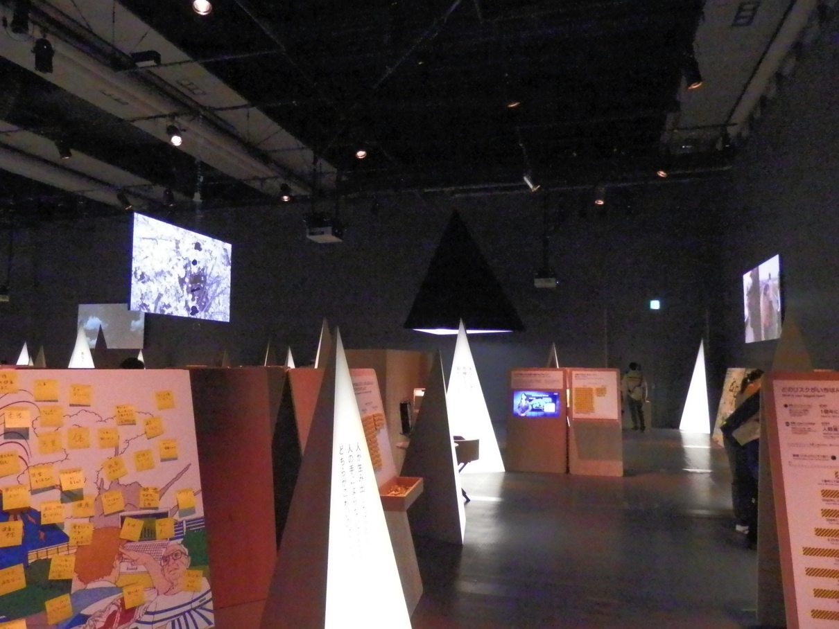

The responses to the questions could be at times both humorous and moving. One sign asks ‘Are there things that have disappeared due to technological advancement?’ Responses include: ‘waste,’ ‘guts,’ ‘waiting time,’ ‘considerateness,’ ‘the self’. What do you want to do during the time left to you? ‘sleep,’ ‘smile,’ ‘laugh,’ ‘it depends how long is left,’ ‘spend time with the people that are important,’ ‘to live normally.’ While compared to the utopian visions prevalent in many representations of the future elsewhere at the museum, visions that seek to pose solutions to current problems or anxieties, this exhibition is quite unusual in that it offers no solutions. ‘Angelus Novus,’ the Klee painting, appears among the artworks placed in the exhibition. Walter Benjamin described the painting as follows:
His face is turned toward the past. Where we perceive a chain of events, he sees one single catastrophe, which keeps piling wreckage upon wreckage and hurls it in front of his feet. The angel would like to stay, awaken the dead, and make whole what has been smashed. But a storm is blowing from Paradise; it has got caught in his wings with such violence that the angel can no longer close them. The storm irresistibly propels him into the future to which his back is turned, while the pile of debris before him grows skyward. This storm is what we call progress (Benjamin 1969: 249).
To say that the exhibition was been influenced by the social climate in Japan would be an understatement. It is a direct response to devastating events in the recent past, both retrospectively orientated and presenting a somewhat fatalist vision of the future. This exhibition, like Benjamin’s angel of history, looks towards the chaos and wreckage of the past as we are propelled ever forwards.
The exhibition is divided into four main sections: Unanticipated Endings, My End, the End of Culture and the End of the Story. In the End of Culture section there is a timeline that charts the rise and fall of various now extinct civilizations. The exhibition considers the impending threat of climate change along with the potential for society, as it currently exists, to endure. One question, which relates to the earlier question of things ‘lost’ due to advances in technology is ‘Can we return to the lifestyle of fifty years ago?’ This question is an inversion of a question found throughout the rest of the museum: ‘What will society look like fifty years in the future?’
On the third floor at Miraikan there is an exhibit titled ‘Lifestyle 2050’ which consists of a scale model of an imaginary future city, ‘Itookashi.’ Interactive terminals present heavily stylized cartoonish depictions of the year 2050 that resemble ‘The Jetsons’ in their imagery. For instance, the residents of this future city travel around in multi-colored egg shaped helicopters that suspiciously resemble the iconic 1960s’ chairs of the same shape. The ‘Lifestyle 2050’ exhibit is not a serious attempt at sooth-saying but rather a playful representation of a utopia based on current social concerns. It could be considered an example of ‘future nostalgia’ (Rosenberg and Harding 2005). Energy, transport and climate needs are fulfilled in this city, the residents are happy flying around in their eggs, the model incorporates lots of green and open space and looks significantly less crowded and congested than Tokyo, as you would expect in an ideal city. The choice of 2050 as the setting for this city year is interesting. The arbitrary significance of this year is that it is roughly half a century away. It is a year that a Japanese person under 40 should expect to live to see. Japan, which has long been celebrated for the longevity of its population, continues to rank first in the world with a current life expectancy of 84 (World Health Organization 2014).
The year 2050 recurs many times throughout the museum in order to represent a notional future. A chalkboard invites visitors to suggest what they think Christmas gifts will be in the year 2050. The question on the board changes daily but often includes this year. Before starting in the field I was already familiar with this date the year by which the proportion of the population over 65 is expected to reach 40%. This impressive life expectancy coupled with a low birth rate has led to an ageing population being increasingly a cause for concern. Fears that the working population might soon no longer have the resources to support the elderly either financially or simply in support labor can be seen in new government policies, such as the ‘Long Term Nursing Insurance’ that asks individuals to contribute towards the care assistance they may depend on in later life. These fears are put into context when you consider that the population of Japan is expected to shrink by 40million by 2055, from its current level 127.8million to 89.93million. There is an increasing sense of urgency towards ‘dealing with’ the aging population.

Fig.2 The character for death drawn with a dead body on a post-it note on a board in response to the question ‘What is the thing you are most worried about in life?’
© Michael Shea 2012

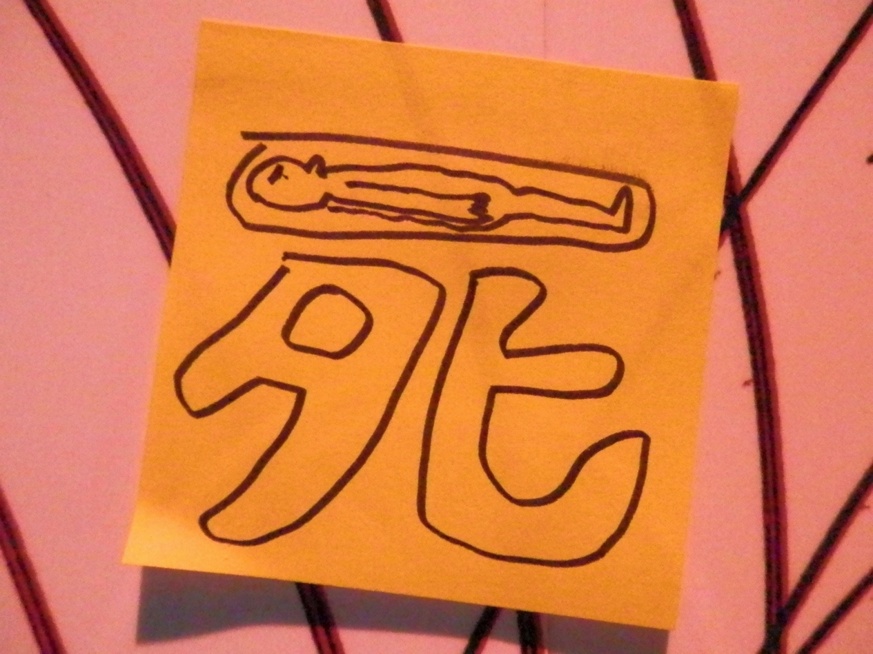

Advances in technology are looked to as a potential social savior for the country. For example, the government led initiative ‘Innovation 25’ announced in 2007 was Prime Minister Abe’s plan for remaking Japanese society by the year 2025, based around the increasing integration of domestic androids. It sets out a blueprint for accommodating the rapidly aging population through such technological innovations. Writing on this proposal Robertson describes how Innovation 25 ‘emphasizes the central role that household robots will play in stabilizing core institutions, like the family’ (Robertson 2007: 370). In my own research into demonstrations of the Honda ASIMO robot, the actions the android would frequently perform (carrying a tray of drinks up and down stairs, fetching following voice commands) all seemed rather tame and domestic for a technology demo, suddenly take on much greater significance once you consider that its designers explicitly refer to home care as one it’s most likely future uses.
In Boia’s Forever Young: A Cultural History of Aging it is argued that since the advent of modernity a kind of ‘secularized religion’ has emerged whereby mortality is transcended not through religious salvation but through notions of collective progress and nationhood. The logic underlying this shift is characterized as follows: ‘Each of us is mortal, but humanity will live on. The only way to give meaning to our lives is to devote ourselves to some grand collective project’ (Boia 2004: 7). In science museums, this ethos can be seen in the potential for a better standard of living in the future provided by technology. This exhibition is significant because it goes against this dominant trope instead to question the uncertainty of life in the future, natural disasters and the limits of human ability to resolve questions of life and death.
The overwhelmingly optimistic ethos of technology as savior which is exemplified in ‘Lifestyle 2050’ is a world away from the ‘Story of the End of the World’ which approaches the same impeding challenges with a sober questioning of whether even the lifestyle of the immediate past can endure. This huge shift of emphasis in the approach to the future reflects the sense of uncertainty following the March 11th earthquake and leads the visitor ask if we might return to the lifestyle of fifty years ago, or at least sustain current living standards rather than to be invited to ponder what a marvelous place the future might be.
Although contrary in their approaches, both the optimistic vision of the future set out in ‘Lifestyle 2050’ and the ‘End of the World’ exhibition and its existentialist musings similarly depend on projecting present social anxieties into the future. Predictions about the future will always to some extent ‘reinscribe the present into the future’ (Collins 2008: 89). While elsewhere in the museum the challenges of an aging population are presented in terms of the emancipatory potential of assistive technologies the root concern with the challenge of longevity is the same. The Tohoku earthquake has arguably altered attitudes towards these perceived future challenges at the museum from an emphasis on improving quality of life to one of survival. Where the question of earthquakes might have been approached as how we might one day be able to accurately predict them, this exhibition reframes this problem as what are the odds of my dying in an earthquake compared to other things or asking whether they might ever be predicted. It is about achieving catharsis by confronting uncertain and uncontrollable things.
All of the exhibits at Miraikan are maintained by the combined efforts of professional staff and volunteers. Volunteers at the museum tend to be people that have retired. Nakano notes that at the time of writing volunteering rates in Japan were highest among men in their sixties and women in their thirties, coinciding with the respective ages where workforce participation was lowest (Nakano 2000: 96). It is interesting then to consider that many of the themes being played out in the exhibition are directly relevant to the volunteers, mortality, future uncertainty, changes in society due to technology and their potential benefits along with what is lost. It is of course ironic that exhibits inspired by the impending crisis of supporting an aging population are largely maintained by retired volunteers, who offer up their labor for free.

Fig.3 A screen capture of the web page where visitor responses to ‘The Story of the End of the World’ can be viewed. © Michael Shea 2012

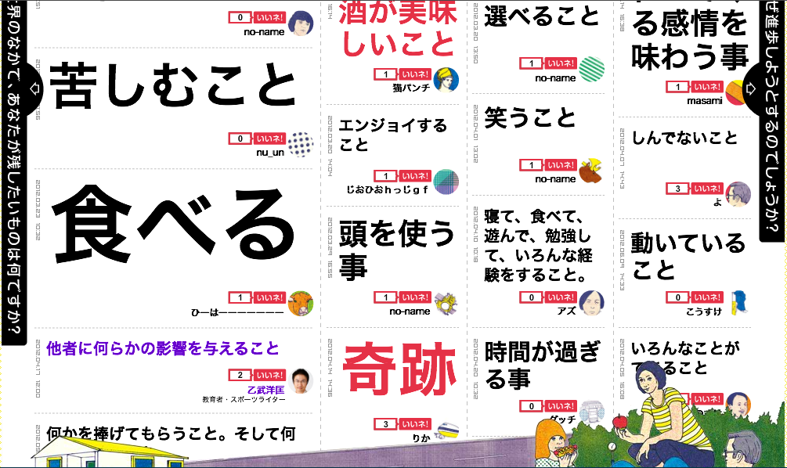

A member of staff once lost patience with me for accidentally referring to the exhibition as ‘the end of life’ rather than ‘the end of the world’. However, this slip of the tongue led me to consider the fact that my mistaken title would have been quite appropriate. In the exhibition there are few, if any, scenarios presented where our planet or all life on Earth would be destroyed. Instead we are met with statistics on national suicide rates and the life span of various mammals, along with different forums for visitors to express their individual anxieties about their own future and mortality. It is really an exhibition about coming to terms with death and loss rather than an attempt to imagine the destruction of Earth, although nuclear war and environmental issues, that could potentially cause an apocalypse, can be seen among visitors’ concerns. Questions such as ‘What would you like to do with the rest of your life?’ are intended to encourage the visitor to ponder their own life rather than to present them with a vision of a future apocalypse.
What singles out the ‘Story of the End of the World’ among Miraikan exhibits that present visions of the future in which missing workers and kin are replaced is that here the loss is never compensated. This loss is felt even in the structure of the exhibition space, in which there is no central object of curiosity or technological sophistication to gaze at. One could argue that absence is at the very heart of this exhibit. In the wake of the Tohoku earthquake and tsunami there is no room for unbridled optimism. Instead the museum presents an uncertain vision of the immediate future in which lost social relations are not easily replaced. In this exhibition the only thing that can fill the void is the visitors and their thoughts. Rather than being faced with a technological utopia or even a Hollywood scenario of the destruction of Earth the visitor is confronted with the uncertainty of the future and the inevitability of their own eventual end of life. By encouraging visitors to articulate what are for the most part negative emotions regarding their own mortality, the exhibition aims to provide a cathartic experience.

References

Benjamin, W. (1969 [1940]) ‘Theses on the Philosophy of History’ Illuminations: Essays and Reflections. New York: Schocken.

Boia, L. (2004) Forever Young: A Cultural History of Aging. London: Reaktion.

Collins, S. G. (2008) All Tomorrow’s Cultures: Anthropological Engagements with the Future. New York: Berghahn.

Miraikan Online. (2012) ‘The Story of the End of the World: Exhibition Outline’ http://www.miraikan.jst.go.jp/spevent/owari/ [Accessed 28 November 2012].

Nakano, L. L. (2000) ‘Volunteering as a Lifestyle Choice: Negotiating Self-Identities in Japan’ Ethnology 39 (2).

Robertson, J. (2007) ‘Robo Sapiens Japanicus: Humanoid Robots and the Posthuman Family’ Critical Asian Studies 39 (3).

Rosenberg, D., Harding, S. (2005) Histories of the Future. Durham: Duke University Press.

World Health Organization. (2014) ‘Life Expectancy at Birth: Both Sexes’ World Health Statistics. http://gamapserver.who.int/gho/interactive_charts/mbd/life_expectancy/atlas.html [Accessed 26 August 2014].

